|  |
| --- |
|  |
| **Newsletter May 2018** |
|  |



# Events

* [Hack Miami](https://unifi.us14.list-manage.com/track/click?u=255c1f7db97ba0542b0808a63&id=226e33a6a8&e=73751e039e) (CFP FL, USA)   
  May 18 - 20, 2018 | Miami, Florida, United States
* [IT & Digital Leaders Nordics](https://unifi.us14.list-manage.com/track/click?u=255c1f7db97ba0542b0808a63&id=1adb8b0c18&e=73751e039e)   
  May 24, 2018 | Stockholm, Sweden
* [International Workshop on Secure Software Engineering in DevOps and Agile Developmen](https://unifi.us14.list-manage.com/track/click?u=255c1f7db97ba0542b0808a63&id=0904b49baf&e=73751e039e)t (SecSE) (CFP Porto, Portugal)   
  May 25, 2018 | Porto, Portugal

|  |
| --- |
|  |
|  |
|  |

## Cyber Policy, Diplomacy & Legal Framework

* [The State Department might designate a cyber ambassador](https://unifi.us14.list-manage.com/track/click?u=255c1f7db97ba0542b0808a63&id=829e6c74d9&e=73751e039e" \t "_blank)  
  After the retirement of former Cyber coordinator, Christopher Painter, the US State  Department effectively removed his position. The Department of State Authorization Act of 2018 sets the basis for the recreation of this office and even going a step further with the creation of a Bureau for Cyberspace and the Digital Economy, run by a Senate confirmed assistant secretary reporting directly to the under secretary for economic growth, energy and the environment.
* [Government to refresh 2015 Cyber Security Strategy and Action Plan](https://unifi.us14.list-manage.com/track/click?u=255c1f7db97ba0542b0808a63&id=04c30ec5cf&e=73751e039e)  
  New Zealand refreshed its approach to cyber security by establishing a CERT NZ, by delivering of CORTEX malware detection and disruption services, by promoting cyber security awareness campaigns and by working to improve the cyber security of small business and developing police skills
* [Is it Time to Regulate Cyber Conflicts?](https://unifi.us14.list-manage.com/track/click?u=255c1f7db97ba0542b0808a63&id=99eb98c1a8&e=73751e039e)  
  According to Microsoft President, Brad Smith, Governments should work together with private tech companies to tackle the growing threat of state-sponsored cyber attacks. Encouraged by positive indications in the international legal and diplomacy arena, Smith proposed a program based on three pillars.
* [Three critical components of a cyber policy](https://unifi.us14.list-manage.com/track/click?u=255c1f7db97ba0542b0808a63&id=91f59929a6&e=73751e039e)  
  Although cyber criminals seem to be one step ahead of the authorities, leading cyber insurance companies are doing a good job of creating broad and forward thinking policies that protect a client in the event of a cyberattack. Here, Insurance Business looks at three of the critical components of a modern cyber policy.
* [How Casper Klynge is reinventing diplomacy as the world's first tech ambassador](https://unifi.us14.list-manage.com/track/click?u=255c1f7db97ba0542b0808a63&id=83fb09ecdc&e=73751e039e)  
  Denmark's representative in Silicon Valley has met with scepticism since taking up his post, but he is convinced others must follow his country's lead

## Cyber Security

* [What Is Telegram, and Why Are Iran and Russia Trying to Ban It?](https://unifi.us14.list-manage.com/track/click?u=255c1f7db97ba0542b0808a63&id=3b07e8a042&e=73751e039e)  
  Telegram,  the cloud-based instant messaging service founded by Russian engineer Pavel Durov, has been recently blocked in Iran and Russia, two of its largest user bases. The social network has already sparked some criticism, when it was disclosed its role as communication tool for terrorists. Now many un-democratic countries are using fear to crack down Telegram and the network of political dissidents, which used it to protect themselves.
* [Twitter users told to change passwords after internal leak](https://unifi.us14.list-manage.com/track/click?u=255c1f7db97ba0542b0808a63&id=08da5e17a0&e=73751e039e)    
  Twitter’s 330 million users got their passwords stored in a easily readable system. The company has encouraged users to change the passwords for caution, since no account result stolen or damaged.
* [British and Spanish leaders say Russian trolls meddled in their elections](https://unifi.us14.list-manage.com/track/click?u=255c1f7db97ba0542b0808a63&id=f68bbae288&e=73751e039e)  
  Britain and Spain accuse Russian government of pushing respectively for Brexit and Catalonian Referendum, through massive fake news campaign. The leaders have not revealed any evidence and Putin has replicated suggesting that Western countries are using Russia as scapegoat for their internal failures.
* [Cybersecurity risks to get worse: Warren Buffett](https://unifi.us14.list-manage.com/track/click?u=255c1f7db97ba0542b0808a63&id=3417778524&e=73751e039e)    
  Warren Buffet, Berkshire Hathaway CEO, warns that "Cyber is uncharted territory. It's going to get worse, not better”. Cybersecurity risk is more difficult to assess than other threats, nowadays.

## Cyber Warfare, Intelligence and Terrorism

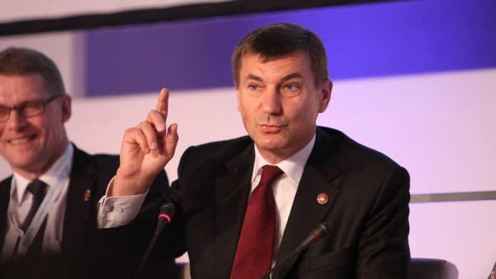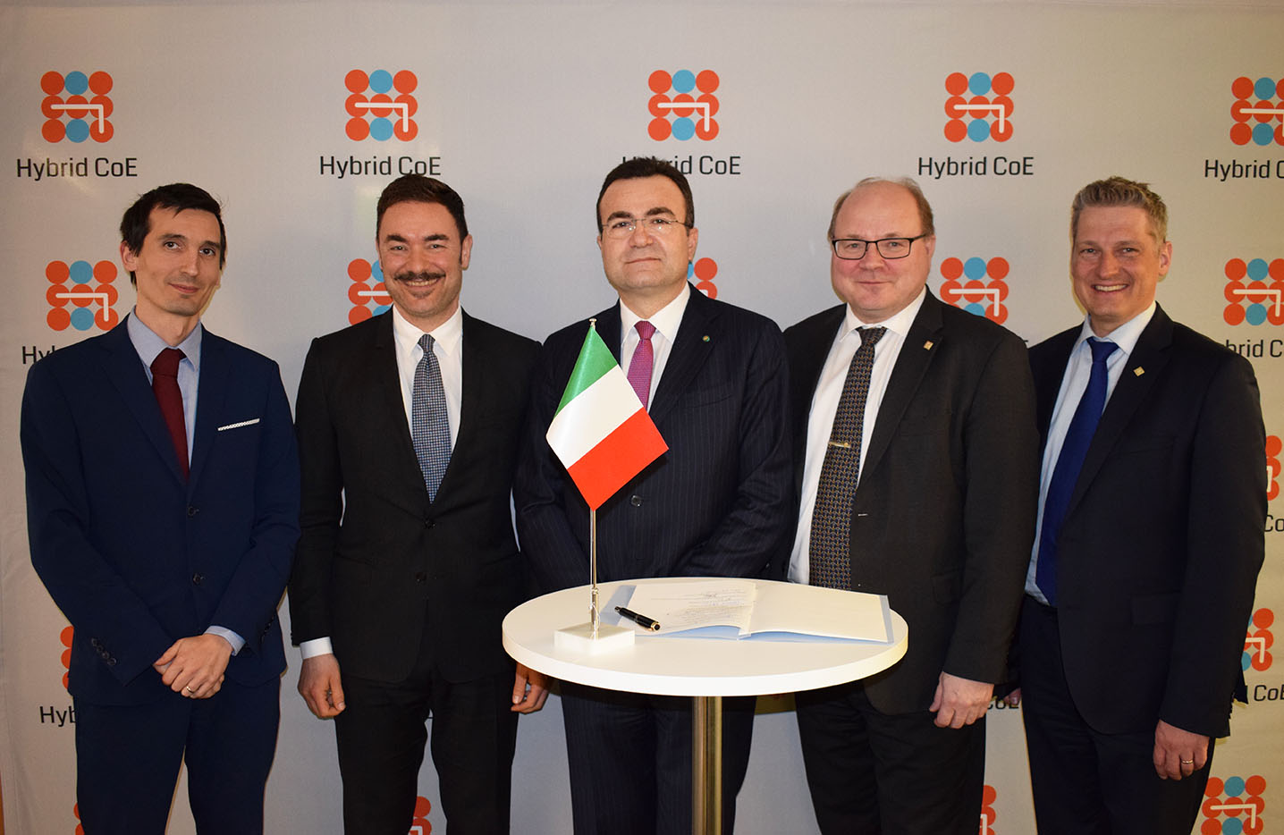

* [Pentagon's Cyber Command Gets Upgraded Status, New Leader](https://unifi.us14.list-manage.com/track/click?u=255c1f7db97ba0542b0808a63&id=f30f55be6a&e=73751e039e)    
  The Pentagon has recently incremented its cyber warfare and digital unit, indicating an increasingly important role of this sector in the US national defence and security system. Army Gen. Paul Nakasone has been named chief of the Cyber Command, as well as Director of the NSA. This appointment seems to suggest that US are taking more and more seriously the cyber threats, both from non-state actors (ISIS) and from major countries (China and Russia).
* [Drones used to disrupt FBI hostage situation](https://unifi.us14.list-manage.com/track/click?u=255c1f7db97ba0542b0808a63&id=1615e38b2c&e=73751e039e)  
  Criminals reported to use drones to disrupt FBI hostage situation. This is the last of a series of criminal use of UAV, which is worrying police.
* [Cyberwarfare, populism top 'black swan' events at Milken conference](https://unifi.us14.list-manage.com/track/click?u=255c1f7db97ba0542b0808a63&id=2d939ad8d9&e=73751e039e)  
  Cyberwarfare and populism are some of the top risks that could threaten global stability and financial markets, investors and policymakers warned at the annual Milken Institute Global Conference.
* [What a cyberwar looks like — and what it doesn't](https://unifi.us14.list-manage.com/track/click?u=255c1f7db97ba0542b0808a63&id=23f6f3fe3d&e=73751e039e)  
  President and Chief Legal Officer Brad Smith of Microsoft in April told the RSA cybersecurity conference about attacks that don't involve tanks and warplanes, but bytes and bots. And they are aimed at our energy grids, our infrastructure, and even our private financial information
* [By staging war games, NATO members prepare for cyber attacks](https://unifi.us14.list-manage.com/track/click?u=255c1f7db97ba0542b0808a63&id=f164076d43&e=73751e039e)  
  The world’s largest live-fire cyber defense exercise is helping NATO members prepare for cyber warfare. Over the last eight years, 22 NATO and EU countries have been practicing the scenario of a cyber attack in Locked Shields, a war game run by the NATO Cyber Defence Centre of Excellence.

## Cyber Opportunities: Economy, Research & Innovation

* [Private Companies Take the Lead on Cyber Security](https://unifi.us14.list-manage.com/track/click?u=255c1f7db97ba0542b0808a63&id=f56caa07a5&e=73751e039e)  
  The Cybersecurity Tech Accord  is a remarkable initiative by a group of 35 key technology and security companies like Cisco, Facebook, Microsoft, Nokia and Oracle. It is a public commitment to protect and empower civilians online and to improve security, stability and resilience in cyberspace.
* [Georgia governor vetoes cyber bill that would criminalize “unauthorized access”](https://unifi.us14.list-manage.com/track/click?u=255c1f7db97ba0542b0808a63&id=d050b533d7&e=73751e039e)  
  After many weeks of opposition from information security firms and professionals, Georgia Governor Nathan Deal vetoed a bill that would have criminalized unauthorized access of computer systems.
* [Facebook publishes new content moderation guidelines](https://unifi.us14.list-manage.com/track/click?u=255c1f7db97ba0542b0808a63&id=652ca4f0f8&e=73751e039e)  
  Zuckerberg’s social network implemented the expected new, post Cambridge Analytica, user standards urging the Facebook community to “share responsibly”.
* [Goldman Sachs to Open a Bitcoin Trading Operation](https://unifi.us14.list-manage.com/track/click?u=255c1f7db97ba0542b0808a63&id=e88a58767f&e=73751e039e)  
  Goldman Sachs will finally launch its widely-rumoured bitcoin trading operation after having hired its first digital asset trader
* [JPMorgan Chase is doubling down on artificial intelligence.](https://unifi.us14.list-manage.com/track/click?u=255c1f7db97ba0542b0808a63&id=c033d69cf3&e=73751e039e)  
  The American bank has hired Manuela Veloso, a top researcher from Carnegie Mellon University as its first head of artificial intelligence research.

## Italian Focus



* [Professioni Ict, fra tre anni in Italia 135mila posizioni scoperte](https://unifi.us14.list-manage.com/track/click?u=255c1f7db97ba0542b0808a63&id=8e1023c89b&e=73751e039e)  
  The gap between supply and demand in the Italian ICT labour market will rise by up to 18% in 2020. Notwithstanding the clear signals coming from the market, the Italian education system keeps investing in ICT diplomats instead of in graduates.
* [Italy joins Hybrid CoE](https://unifi.us14.list-manage.com/track/click?u=255c1f7db97ba0542b0808a63&id=4f60c37323&e=73751e039e)  
  On the 24th of April, Italy became the 15th member state in the European Centre of Excellence for Countering Hybrid Threats.
* [Cybersecurity: perché stanno raddoppiando gli attacchi nella sanità?](https://unifi.us14.list-manage.com/track/click?u=255c1f7db97ba0542b0808a63&id=c52baaf086&e=73751e039e)  
  According to the latest report issued by McAfee Labs on Cyber threats, 2017 has been a terrible year for the health sector: cyber attacks tripled in comparison to 2016
* [Recepimento direttiva Nis, Italia è in ritardo ma è allarme cyber crime](https://unifi.us14.list-manage.com/track/click?u=255c1f7db97ba0542b0808a63&id=1c7f67d038&e=73751e039e)  
  Notwithstanding its relevance, the current Italian political deadlock is slowing the implementation of the new NIS directive.
* [Formazione, Poste spinge sulla networking security. E si allea con Juniper](https://unifi.us14.list-manage.com/track/click?u=255c1f7db97ba0542b0808a63&id=d4938a0f3a&e=73751e039e)  
  Network security specialists Juniper Networks and Poste Italiane, will jointly deliver a cycle of university classes on information security for Master’s students.

## European Focus

* [EU to force tech firms to hand over terror suspects' messages](https://unifi.us14.list-manage.com/track/click?u=255c1f7db97ba0542b0808a63&id=311468ebdd&e=73751e039e" \t "_blank)  
  The European Commission plans to give judges the power to issue transnational production orders for information held by service providers in other EU countries. These come with short time limits for compliance to improve the ability of law enforcement agencies to conduct effective investigations.
* [European Commission welcomes new EU-wide cybersecurity laws](https://unifi.us14.list-manage.com/track/click?u=255c1f7db97ba0542b0808a63&id=ffe1aa9f87&e=73751e039e)  
  The new NIS Directive is considered by the EU Commissioners as a “turning point”. Indeed the Directive is the first legally binding EU instrument concerning cybersecurity.
* [Joint Statement by EU Commissioners on the new NIS Directive](https://unifi.us14.list-manage.com/track/click?u=255c1f7db97ba0542b0808a63&id=721a56135d&e=73751e039e)  
  On the 4th of May, several Commissioners including Andrus Ansip, responsible for the Digital Single Market, issued a statement on the first EU-wide legislation on cybersecurity.